## **"Flexi-Digger"** - a flexible robotic arm for tight spaces

*Team [ Nelson, Bentley, Silas, Luke ]*

Many artifacts are hidden in dangerous caves, narrow tunnels, or under collapsed ruins where big, rigid bulldozers can’t fit and humans shouldn't go.

### Part 1: The Problem (Why do we need this?)

Judges want to see that you understand the "pain points" of real archaeologists.

* **The Issue**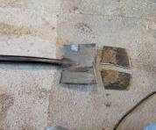 Traditional excavation tools (shovels, backhoes) are rigid and straight. They cannot bend around corners.
* **The Danger:** Archaeologists often have to crawl into "tight spaces"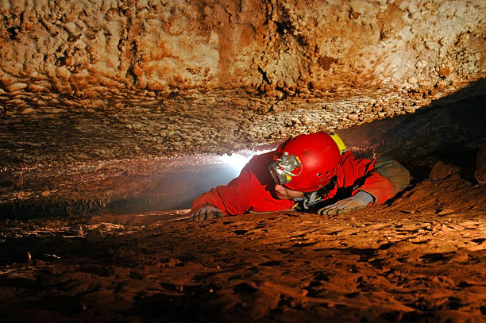
* (like caves or burial shafts) where there is a risk of rockfall, lack of oxygen, or inhaling toxic dust (like in ancient Egyptian tombs).
* **The Risk to Artifacts:** Big machines crush fragile pottery.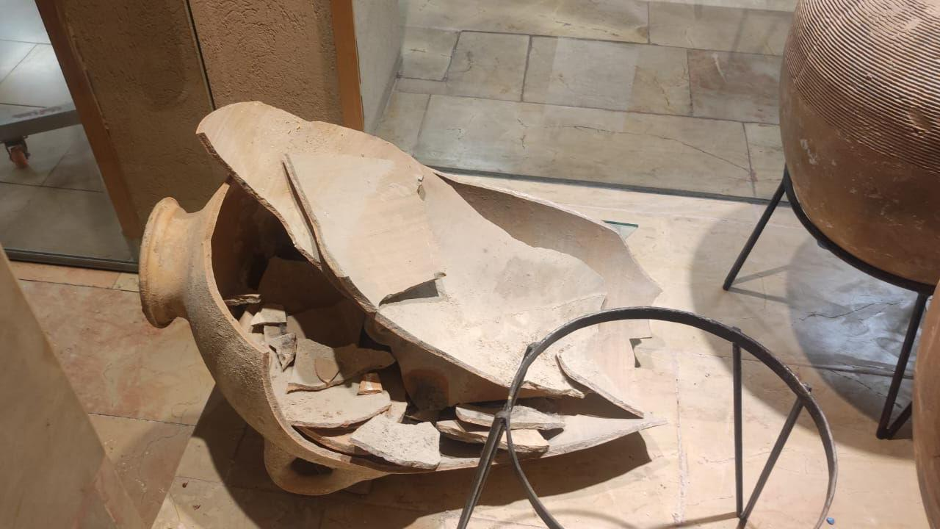 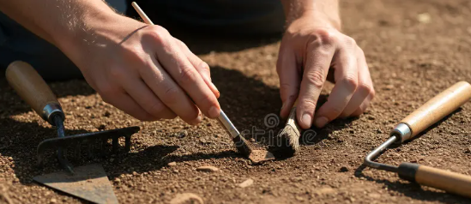Hand digging is safer for the artifact but dangerous for the human.

### Part 2: Your Research (What already exists?)

You need to show you looked at current technology. You can mention these real-world examples in your presentation to impress the judges:

1. **Snake Robots (Inspection):** 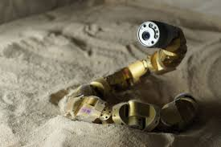Engineers already use "snake robots" (like those from Carnegie Mellon University) to *look* inside Egyptian pyramids and caves. *Limitation:* Most can only look with a camera; they aren't strong enough to dig.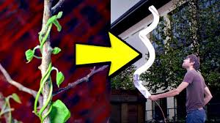
2. **Vine Robots (Soft Robotics):** There is a type of soft robot called a "Vine Robot" that grows like a plant root by inflating. It can squeeze through tiny cracks. *Limitation:* It is usually made of soft plastic and can't move heavy dirt.
3. **Mole Crab Robots:** Scientists have built robots (like "EMBUR") that mimic mole crabs to burrow vertically into sand using flexible legs.[[1](https://vertexaisearch.cloud.google.com/grounding-api-redirect/AUZIYQGrMKsXIQnXqW1MOeJ0ZZ3zpMwNwHDzEQ4jMOitzkRjssxkXZm0ox-9GJrUF28viQ8pQlkota7q0-3QFyIDjWUsaXUBPXdc9_48357DG474rybJmwQE44Fv-o-zzJEO5nOYq5-V758FKGi3ZHf-YpnmbIJMu1fpYS55uK32rt6rFTDRya0QJR1pXzJBMQCNBk6JYJ6mWRA=)][[2](https://vertexaisearch.cloud.google.com/grounding-api-redirect/AUZIYQEtux7u7cnspiLv-ulVKumBqqshUSSa8y4zLqFXIfInd-dapgjXITUs4aY5L8AvAb0bfmFcjgH6kVkN7JE5thUHuMLCRYJLUZgs5x09MtFa5c3Y992VJO51j1mU90z4NVIdh1CP8tMqAdpRZytzbVT6MoZ_Wej81LxpuTGUvDnqaOqYjw08U6qblmGrrbXQaMR1gM0=)]

### Part 3: The "Flexi-Digger" Solution (Your Innovation)

Here is how you can describe your invention to make it sound professional and innovative.

**Core Concept:** The Flexi-Digger is a **Cable-Driven Articulated Arm**.

* **Cable-Driven:** The heavy motors and batteries stay *outside* the cave with the human operator. Only the lightweight arm goes inside. Thin steel cables (like bicycle brake cables) run from the motors through the arm to pull and bend it.
* **Articulated Segments:** Instead of one long stick, it is made of many small "vertebrae" (like a backbone). This allows it to slither into S-shapes to get around fallen rocks.
* **Soft Excavation (The "Secret Weapon"):** Instead of a metal claw that might break a vase, the tip uses **"Granular Fluidization."**
  + *How it works:* The tip blows a gentle stream of air to "loosen" the dirt (making it act like a liquid) and then a soft vacuum hose sucks the dirt away. This reveals the artifact without scratching it!

### Part 4: Building the LEGO Model (For the Competition)

You need a physical model to show the judges. Since your robot needs to be "flexible," standard LEGO bricks are too stiff. Here is a cool engineering trick to build a working flexible arm with LEGO Technic:

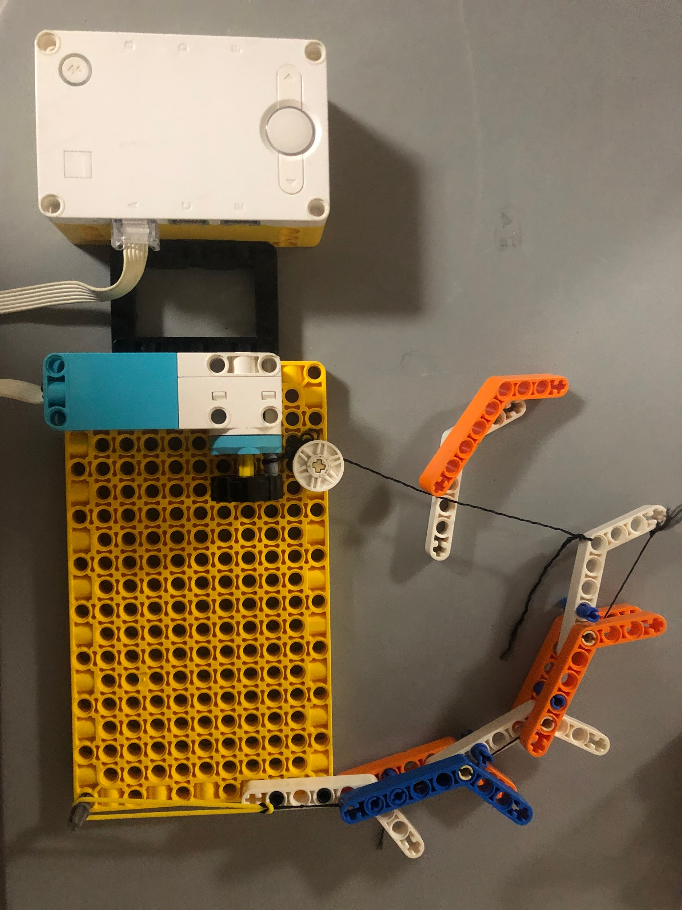

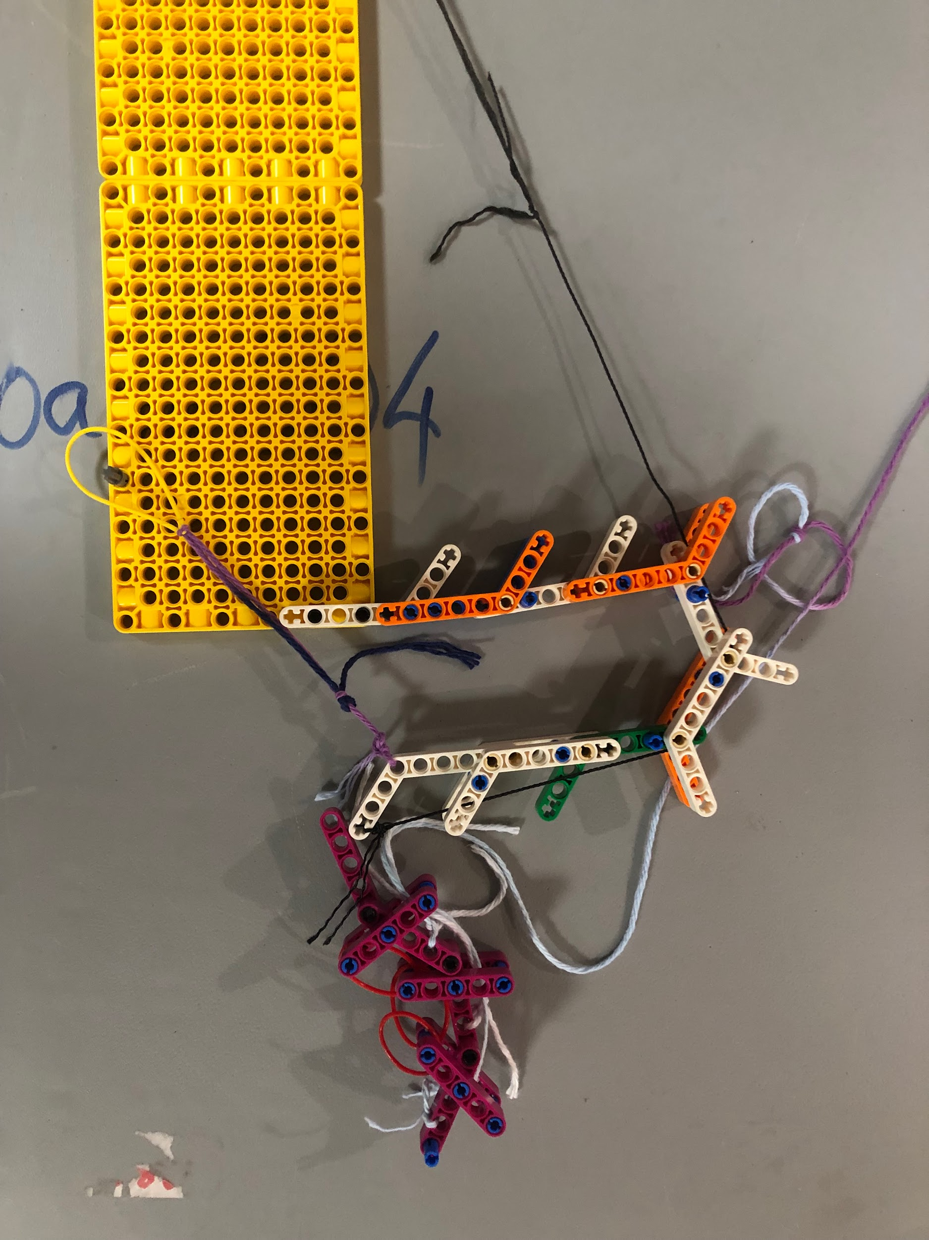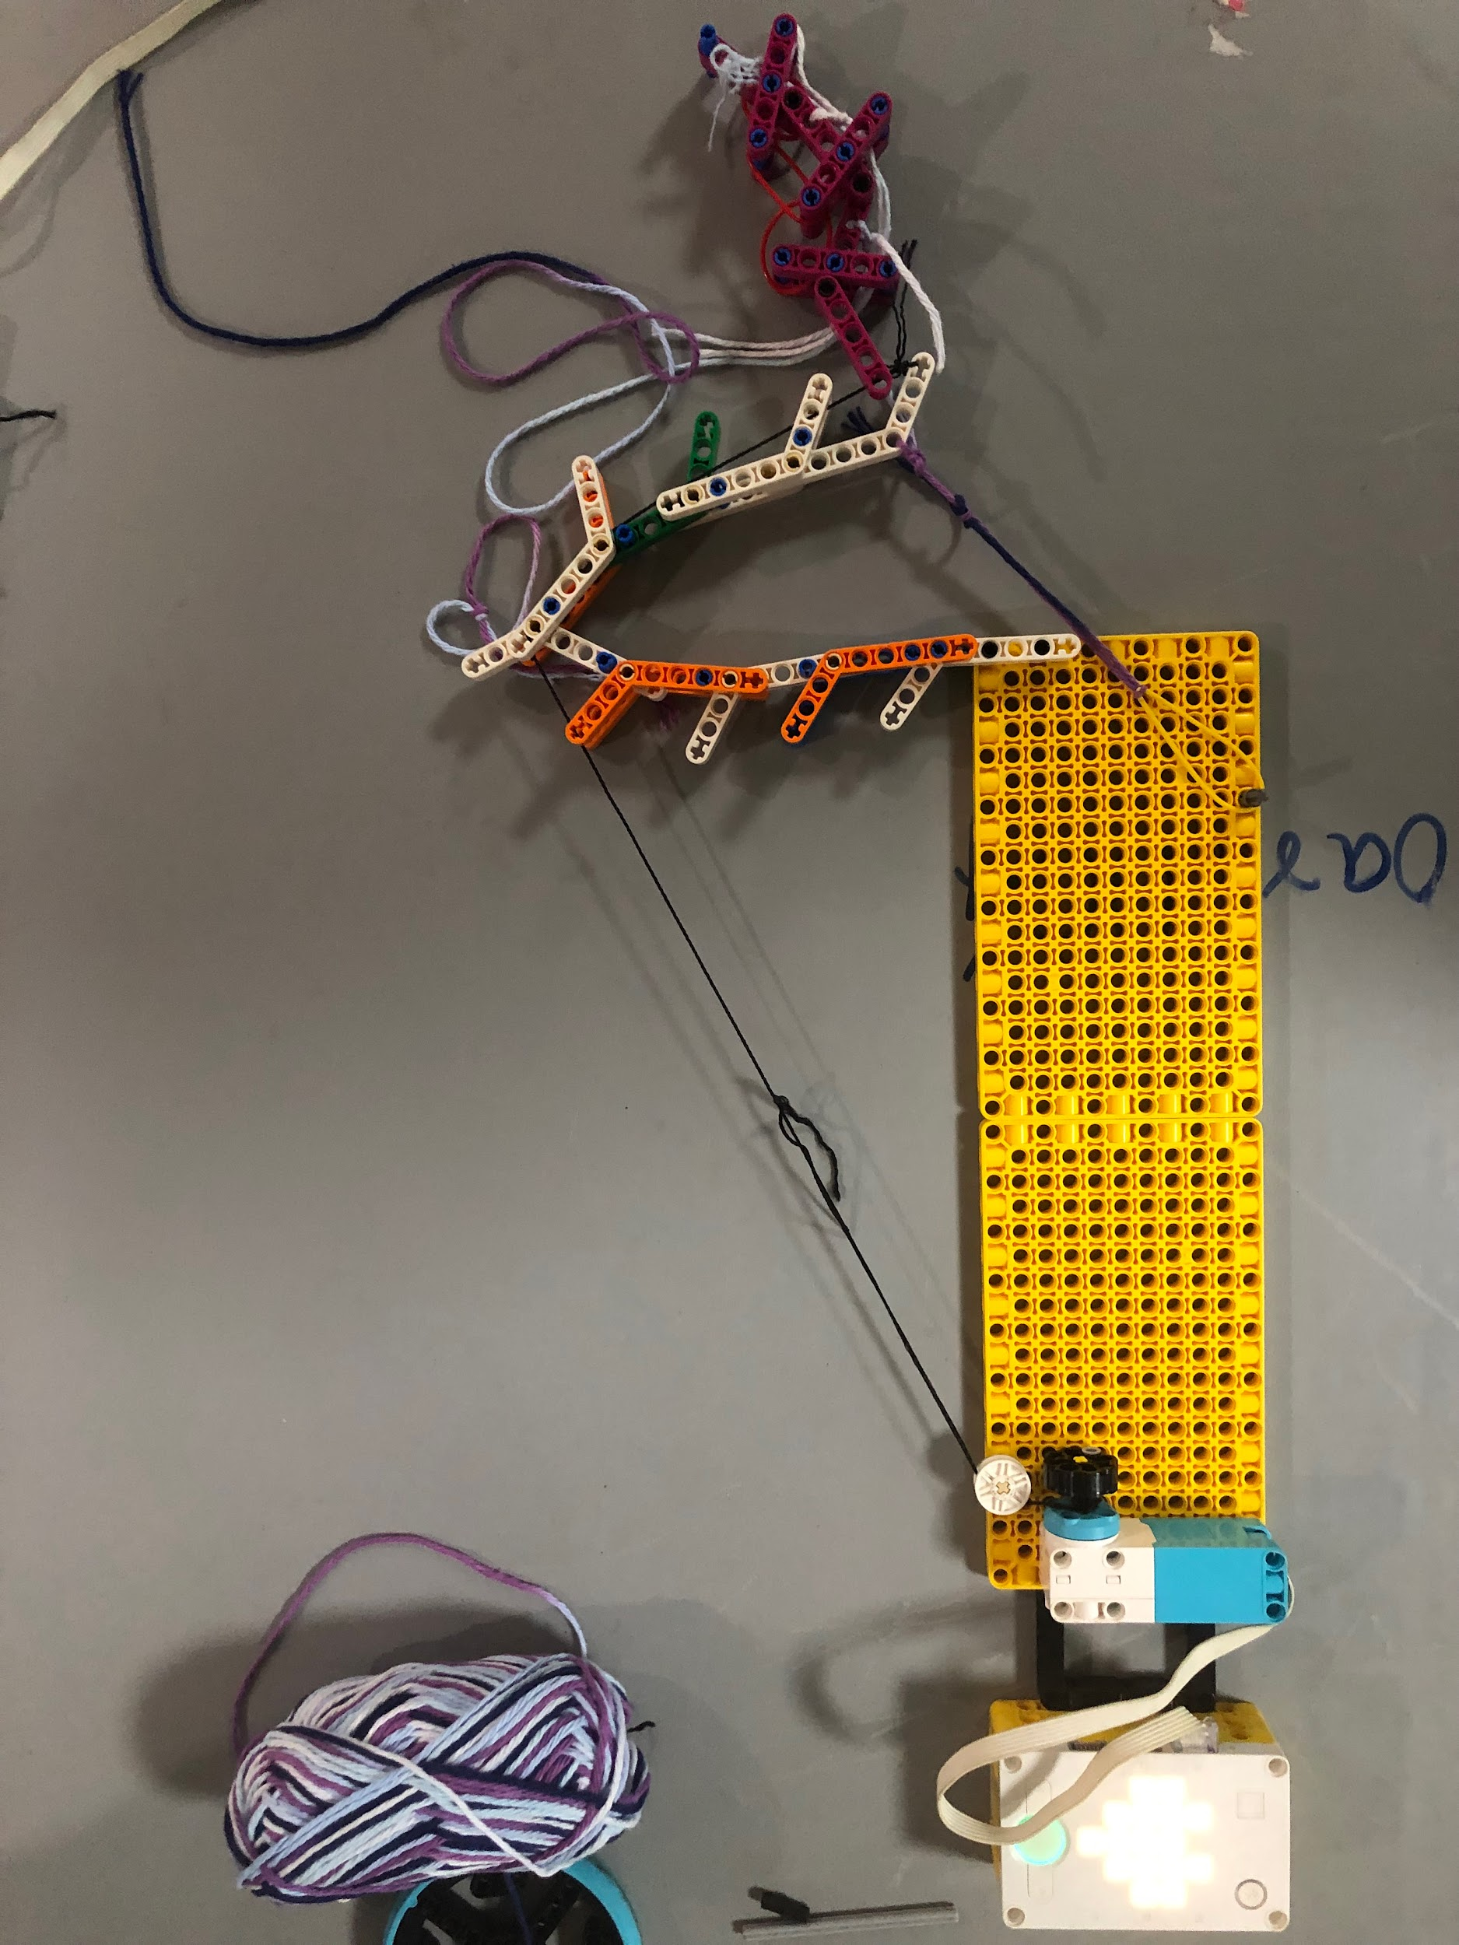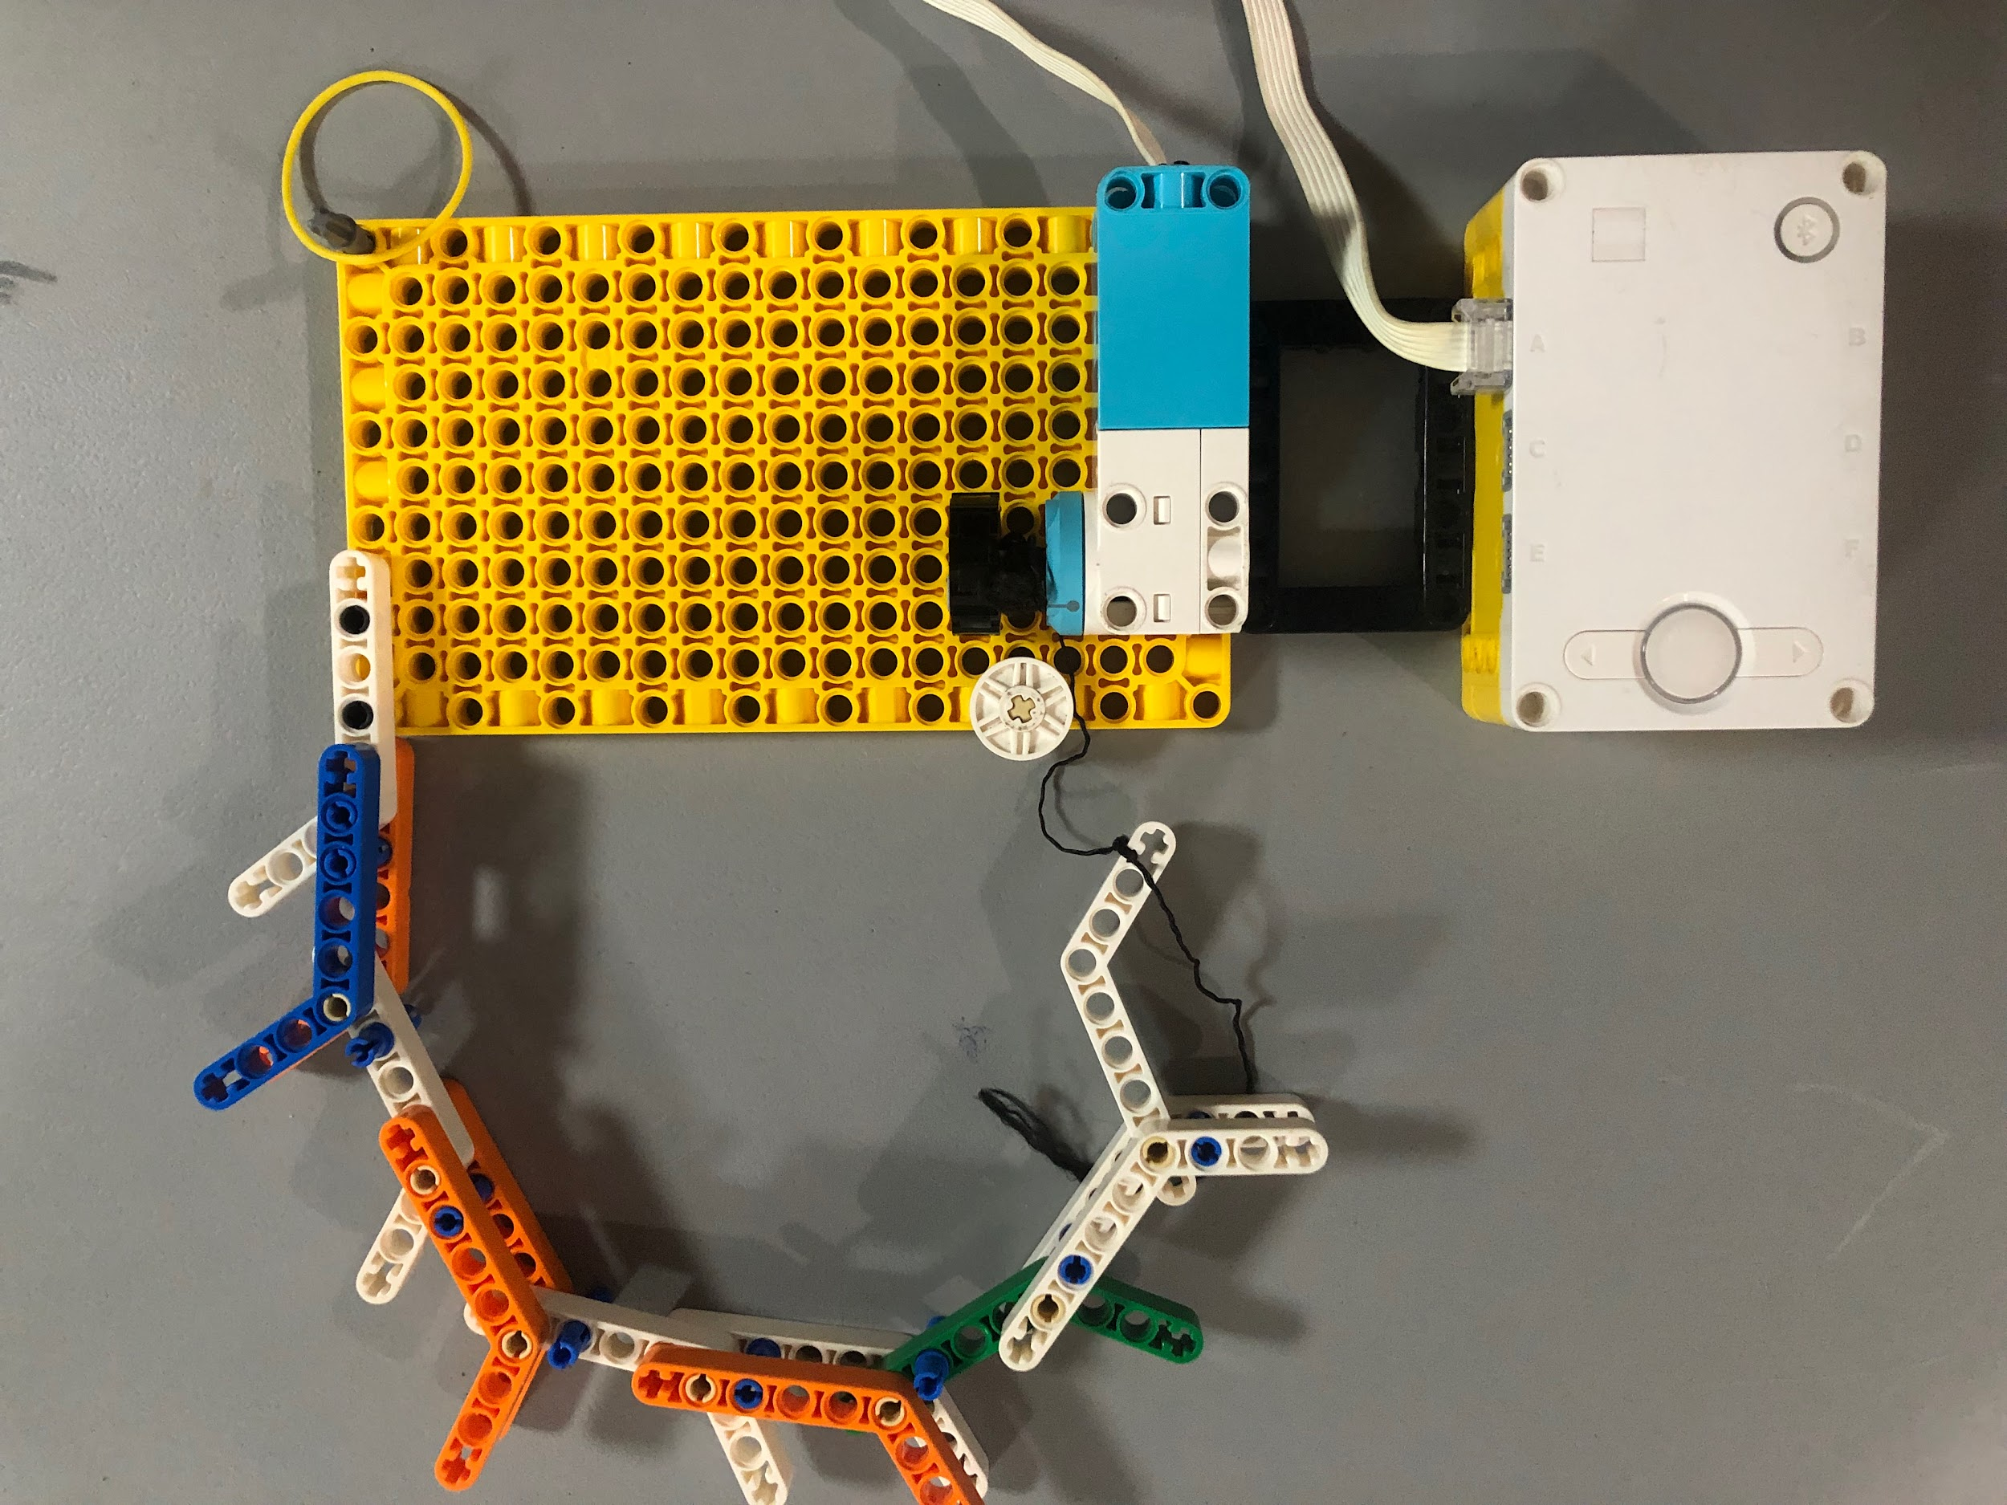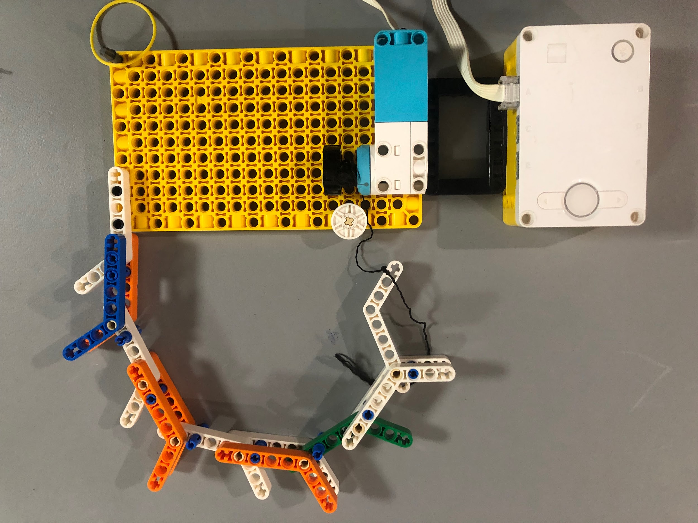

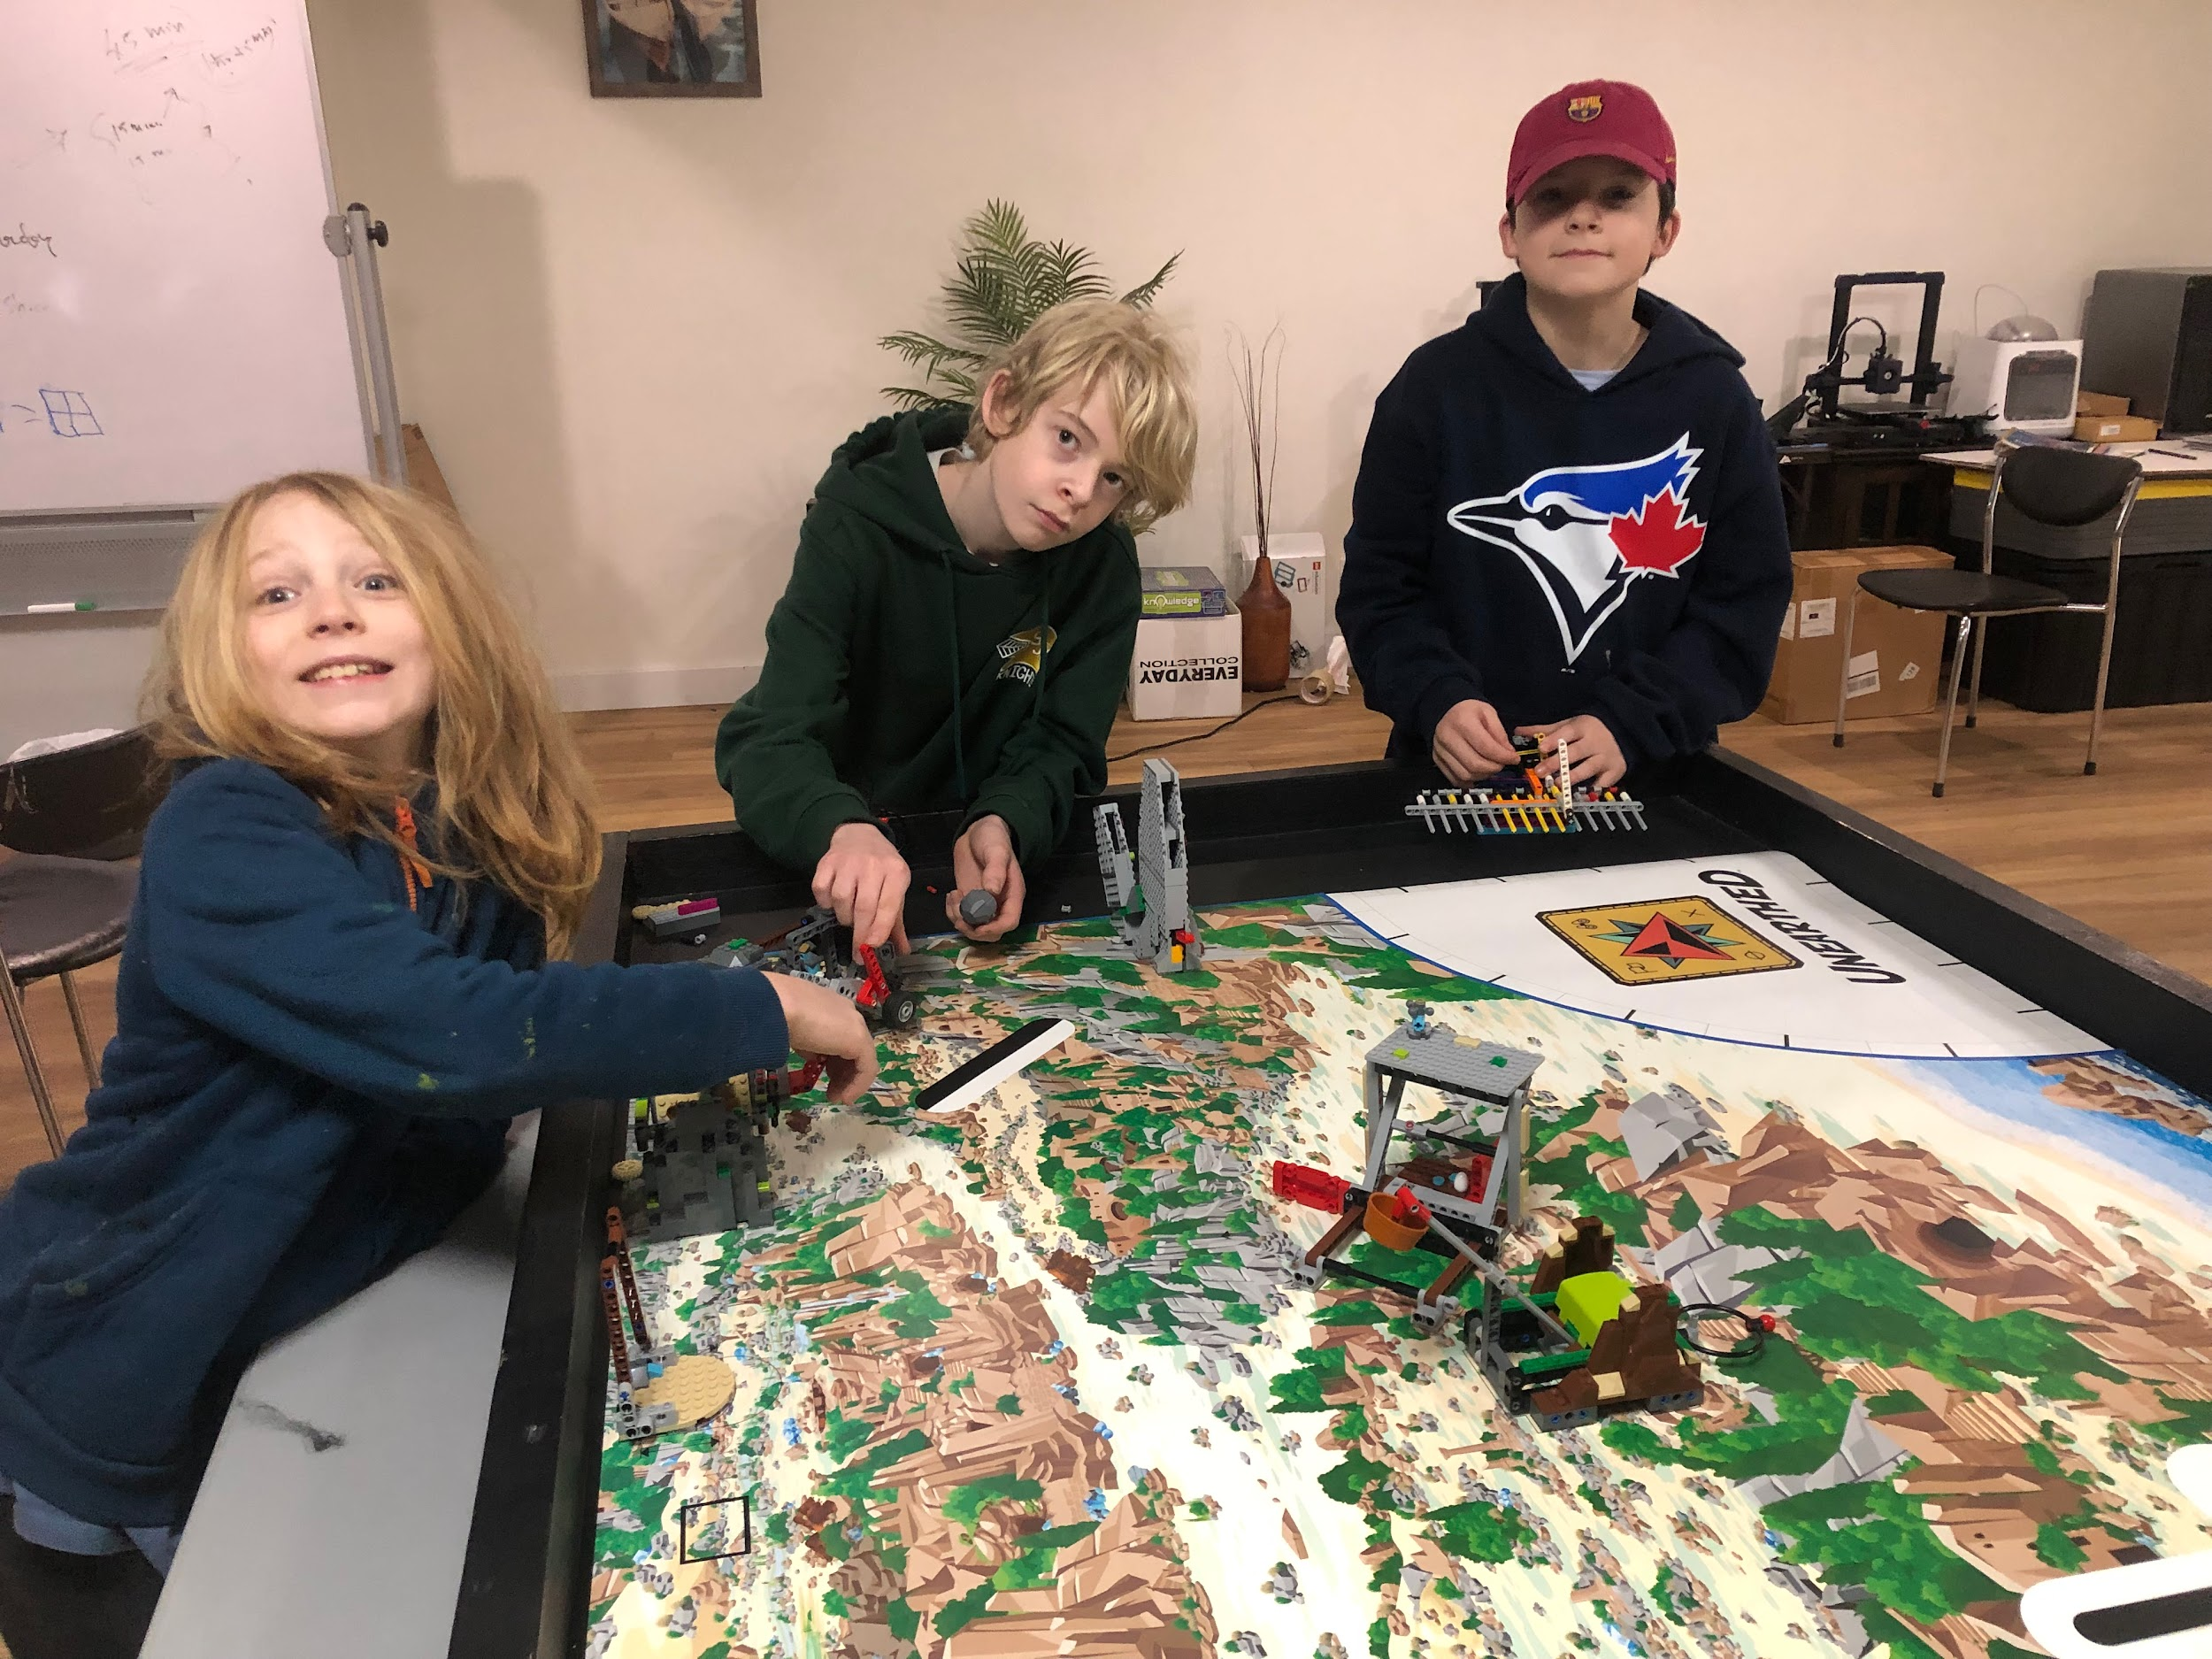

**The Mechanism: The "Tension Spine"**

1. **The Spine:** Use **LEGO Pneumatic Tubing** or the **Ribbed Tubing** (the black flexible kind) as the center of your arm.
2. **The Segments:** Thread widely spaced Technic beams or round spacers onto the tubing.
3. **The Tendons:** Tie a string to the very end of the arm (the "hand"). Thread the string back through holes in the beams all the way to the base.
4. **The Control:** Connect the string to a **LEGO Motor** or a hand-crank wheel at the base.
5. **Action:** When you turn the motor/crank, it pulls the string (the "tendon"), causing the flexible spine to curl up like a finger!

**Bonus Detail for the Model:**

* Add a small **LEGO propeller** or **pump piece** at the tip to represent the "Air Jet" for loosening soil.
* Build a "Control Station" where the operator minifigure sits safely *outside* the dangerous tunnel.

### Part 5: The Presentation Pitch (Script Ideas)

When you stand before the judges, assign roles. For example:

* **Nelson (The Archaeologist):** "We want to explore a tomb discovered under a busy city, but the entrance is an unstable, winding tunnel only 1 foot wide. If we send a human, the tunnel might collapse. If we use a drill, we destroy the history."
* **Silas (The Engineer):** "That’s why we created the **Flexi-Digger**. Unlike rigid robots, our arm uses a cable-driven spine to bend around 90-degree corners. It keeps the heavy motors outside for safety and uses a 'soft-air' jet to blow dust away from artifacts gently."
* **Together:** "With Flexi-Digger, we don't just dig the past; we protect it for the future."

**Good luck, Team Excavators!** If you can get your LEGO model to actually curl when you pull a string, the judges will be very impressed.